Final Project Report
For
School Connnect.me
www.schoolconnect.me


Table of Contents

Table of Contents ii
Revision History iii
Group Members iii
1. Final Project Summary i
1.1. Content Summary i
1.2. Lessons Learned ii
1.3. Learning Outcomes Summary ii
1.4 Communications iii
1.5 Critical Thinking iii
1.6 Network Design iv
1.7 Systems Administration and Scripting iv
1.8 Security iv
1.9 Employability v
1.10 Future directions v
2. SYSTEM REQUIREMNETS vi
2.1 Literature Survey vi
2.2 Functional Specfications vi
2.3 Non-Functional specfication xii
2.4 Software Tools Specfication xii
3. Design Specfication xiii
3.1 Modular design xiii
3.2 Syestem Design xiv
3.2.1 Data Flow Diagrams xiv
3.2.2Use case Diagrams xiv
3.2.3 Context Diagrams xxii
3.2.4 School Connect Entity Realtion Diagrams xxiv
4.0 Connection & Collection of Data Process Model xxvi
4.1 Data Crawling form online xxvi
4.2 Data Connection xxvii
4.3 Information Evaluation xxviii
5.0 Team Structure xxix
6.0 Work Breakdown Structure xxx
7.0 Final Over View xxxi
7. Appendix A: Vision and Scope xxxi
8 Appendix B: Status Report 1 xxxi
9. Appendix D: Presentation Slides xxxi
10. Appendix E: Other Deliverables/Artifacts xxxi

Daigrams Refrences :
3.1 Client Screen flow xiv
1.1 Login xiv
1.2 Registration…………………………………………………………………………………………xiv
1.2 School Connect Home Page xvi
1.3 School Wall Page xvii
1.4 School Blog Page xvii
1.5 Profile Page xviii
1.6 Search School Page xviii
1.7 School Connect List Page xix
1.8 User Photo Page xiv
1.9 Level DFD xxi
1.10 ERD xxiii

Revision History

Name | Date | Reason for Changes | Version
Shankar Katkala | 12/08/2014 | Initial Draft | 1.0
Shankar Katkala | 03/16/2015 | Initiation | 1.1
Praveer Panghal | 04/08/2018 | Changes and additions in scope | 1.2

Group Members

Name | Role | Responsibilities
Shankar katkala | Project Manager & Infrastructure SME | Oversee project activities, supervise solution integration into existing infrastructure
Shankar Katkala | Database & Hardware SME | Install & design database, supervise server hardware implementations
Alok Kumar | Interface & Encryption SME | Build user interface and make recommendations for secure network traffic transmission
Praveer Panghal | Information Technology Leadership | Responsible for reviewing and prioritizing all project requests.
Architecture of System is Confidential Not disclosed publically.

Final Project Summary
Schoolconnect.me is connecting the schools, Colleges, University, Private Institutes, Training Institutes and Research development Centers all over the world.

They can share the information about the Specialties, Educations details, Circular Activities and Research Development etc. School Connect.me is user friendly easy access to any users from school professor, students and Parents.
Schoolconnect.me will help the Companies to recruit the students and Do more activities.

We define social network sites as web-based services that allow individuals to construct a public or semi-public profile within a bounded system, articulate a list of other users with whom they share a connection, and view and traverse their list of connections and those made by others within the system.

Content Summary
Scope

Schoolconnect.me is an application, that is connected all over the Schools, College, University and Institutes Connect at one place and share the information with public On Social Network.

Schedule

This began of Phase-I Dec 15, 2014 and will continue through August 30, 2018 with the implementation of the system and first two years of connecting the Users for this site.

Costs

Hardware and Software costs include the PC to interface with the application and database, other peripheral hardware required at both the customer site as well as the offsite facility.

All additional costs have been development, software and programming time.

Communications Strategy

The team utilized several communication methods to collaborate with each other; including email, instant web meeting technology, voice calls and voicemail. The team also used both email as well as Microsoft Software to keep notes on meetings, and other conversations.

We utilized regular meetings with both the Users as well as the business practitioner to solicit feedback for improvements and changes.

Objective:
We are making Schoolconnect.me is single source of site to connect all over world school.Schoolconnect.me lets you inform friends or followers about school’s day to day activities, new development and research going on university.

The objective of the project is to explain and elaborate the concept of “Schoolconnect.me” to the users, hence providing a reliable and efficient Communication online so as to assist users to afford it without much trouble.

- To have attractive and Secure Login page to access.
- Make new user account in more user friendly and proper validation of details.
- Search People easily on entire network.
- Send Friend Request to other users to make friends.
- Add friends to your friend box accept request.
- Creating a public profile having social, professional and personal information.
- Ease of editing of profile anytime.
- Chat with Online friends.
- Upload and Share Images on network.
- Add, Search and shares videos of YouTube.
- Send messages to other friends.
- Reply directly to incoming user messages.
- Post day to day activities, new development and research going on university.
- Administration page to keep eye on user operation.
- Easily password recovery processing.

Concrete and verifiable goals / (Low-level) Problem statement
The concrete goals and the verifiable goals of the project are:
- To design an online social network, that is mainly developing for the purpose of campus life activities and a source of academics.
- To conduct a survey to know which features are missing from the old existing social networking website.
- To design a platform that will make campus student to keep up their relationship with their fellow student and to reach out to the
- ones they have not met.
- To design a platform user can share some knowledge materials, books that are related to their study field and questions/answers.
- To identify some new features, that can be added to social network within an organization of student through the means of a survey.

Lessons Learned
Our primary lesson learned was to dig deeper into the actual use of the final product. Who would use it, what would be their workflow. After careful consideration, we determined that the web portion of the system should have been added to a future enhancement since the employees at the offsite storage would not be granted access to other Social Network sites

A redesign of the screens would have been unnecessary for this project, had the design team gone to the customer sites prior to designing the management screens and done a workflow study. This resulted in changes to the primary management interface to allow for easier workflow when creating and sending daily cases of media to the offsite storage facility.

Learning Outcomes Summary
The learning outcomes were met by a variety of ways the following is a summary for each section and then following the summary is the detail for each section.

1.3.1 Communications outcomes are met through email, WebEx meetings, and phone calls are documented in the Communications Log in Appendix E. Additionally, ideas develop into working components, and the flow of ideas can be seen in the transition.
1.3.2 Critical Thinking outcomes are seen by the team’s approach to solving the management of portable media through email communications in the Communications Log and the project white papers.

1.3.3 Network Design outcomes were met as demonstrated through diagrams and with a VPN to access the network.

1.3.4 Management Information Systems outcomes are document in email communications in the Communications Log where the business practitioner provided feedback to the team.

1.3.5 Systems Administration and Scripting are documented throughout Status Report One example of Systems Administration is the backup plan in section Status Report.

1.3.6 Security is documented and acknowledges that vulnerabilities may be introduced when adding a new server and describes the encryption used for the wireless network.
1.3.7 Employability is documented in section 3 of the Vision and Scope in configuration files, diagrams, security plans, etc., that you have included in the Appendices to this document. It’s Confidential

Communications
All members of the team have responded, contributed, and interacted well with each other throughout the capstone project. Assignments have been completed in a timely manner with few grammatical errors, using correct terminology, and in an organized easy to read fashion in the correct Standard format. Specifically, the weekly deliverables demanded enough work that teammates would have to quickly divide the work, complete tasks, and submit the work back to the group for review. Submitting tasks back to the group gave teammates an opportunity review the work and provide appropriate feedback.

The WebEx meetings were focused on the project deliverables and provided opportunities for brainstorming, planning, and feedback on submitted tasks. All participants were prepared for the meetings with ideas or questions that were pertinent to the project.

During the meetings and through email, there were times that teammates would challenge each other on the direction or selected method for completing a particular task. These ‘challenges’ often would provide unique insight to the problem and demonstrated the synthesis and understanding of the topic leading to an enhanced solution to the problem at hand.

Critical Thinking
The team members did an outstanding job in the analysis of the management problem with Spino inc. The team’s approach to solving the School connect was based on the following ideals and methods.

- Build a product that considers alternative future uses that is reliable.
- Completely define the problem.
- Decide the fastest and most cost-effective way to solve the problem.
- Use the Software Development Life Cycle using the Waterfall /Agile Methodology.
- Develop with trouble shooting tools or methods that will aid in trouble shooting problems.

One example of the foreword thinking was the suggestion of a team member to add several fields to the database that would aid in troubleshooting problems. The trouble shooting fields added were for date and time stamps, the user who created the record, and the user who modified the recorded. Some developers would not add these fields to conserve disk space, reduce development time, and to speed up the application. However, the number of tables and the expected size of the database will not consume too many resources or noticeably affect the speed of the application. Additionally, it is easier to add the fields during initial development than it is to go back and add fields after the product has been released.

Network Design
This project requires the team to design a network because Spino Inc already had an established network. The project involved one server to be added to a network consisting of servers and over a number of workstations. However, the Spino Inc network administrator provided the team with an overview of the network that described the physical layout and how the DNS, DHCP, and VPN were setup. Using the overview of the network, the team reviewed what was required to connect to the portable media management server both internally and externally. The following are the networking components that were used and reviewed to ensure the team could access the necessary resources.
- How to determine if name resolution is working or not.
- The use of ping, arp, and netstat in the command prompt for trouble shooting.
- Remotely logging into computers with the use of Remote Desktop Protocol (RDP).
- Accessing network resources using a Virtual Private Network.
- Mapping network drives.

Systems Administration and Scripting
The additional systems administration and scripting associated with the new portable backup media tracking system at the Nationwide Children’s Hospital comes with minimal overhead. The Application runs on a any devices laptop computer/Phone/IPad/Tablet and DotNetFramework 4.5. The computer will be joined to the domain for security and integration as well as receive regular updates from the WSUS server and a managed anti-virus application. Operating System and software upgrades will be applied as needed, ensuring that sufficient testing is done before hand to reduce any bugs that could interrupt service on the production network.

Security
Anytime a new server or device is introduced to a network it represents a new potential vulnerability and access point for malicious activity if not properly safe guarded against threats. The new system for portable backup media that will be implemented at the Spino Inc by Team 2 consists of several components that have been thoroughly researched to determine the most effective methods for establishing a strong security posture. Although the system is protected by the existing security controls on the Spino Inc network, it introduces several new features and capabilities that warrant additional security implementations. To start, the new servers will have security patches and software updates applied in accordance with the Spino Inc. Anti-virus software will be installed and maintained in the same fashion making the new servers security compliant to the Spino Inc information assurance standards.
The new system and Upgraded for SchoolConnect.me also makes use of several different web interfaces that will be protected using Transport Layer Security (TLS) and user authentication by username and password. Firewalls will be configured to only allow requests for the web interface to be permitted from the internal network to help prevent its exploitability from external threats. The mobile scanners used for the system introduce a new operating system to the network, Microsoft Windows that will also require monitoring for security patches and software updates as well. They will be placed on a rotational use system that will ensure that administrators will have procession of them on a regular basis to keep them current. Communication between the handheld scanners and the servers will be protected with TLS, and the wireless traffic from the scanner to the wireless access points will be protected with WPA2 using the Advanced Encryption Standard (AES).

Employability
The scope of this project to develop a SchoolConnect.me for the Schools was designed to meet several initial strict requirements. The system had to be developed at minimal cost, development staff consisted of in house personal, required a simple to navigate web interface and be robust enough to provide the tracking requirements of. SchoolConnect.me
The selection of software and hardware products was carefully chosen to conform to the necessary design requirements. SQL Server 2008 was selected as low-cost database solution that could run on minimal hardware, in this case a laptop computer. SQL Server 2008 is also a robust enough application that could be used to run custom a database with report generating capabilities and provide remote data input through web forms via multiple sources. The hand Systems with wireless networking capability provide the necessary portability scan, track, identify and report the media at multiple locations simultaneously. The database and web interfaces were developed with in-house staff, providing future support for database changes, upgrades or the addition of new features or capabilities should the need arise.

The final Product produced by this project successfully meets all the pre-determined design requirements and operational criteria. The makes use of all possible network infrastructure in place, an requires minimal additional components to purchased and no outside contracting to complete the software development.

Future directions

The SchoolConnect.me produced from this project was intended to be a low-cost solution developed by in house staff at Spino Inc Offices As long as the organization maintains staff with the appropriate skill sets, the product can continue to be updated with new capabilities and features added as needed for automation tasks of this business process.

Should the Spino Inc require upgrading to a more robust database server in the future such as Microsoft SQL, data can be upsized and migrated to the new database server. Such an upgrade would require an additional investment in hardware, but the current solution provides a foundation that would make the transition fairly seamless for administrators.
For Spino Inc Consulting, this database and Web Application is a launching point to remove the branding, convert to an SQL database with a full web front end to create a commercially marketable product.

2. SYSTEM REQUIREMENTS
2.1 Literature Survey
The Web-based social networking services make it possible to connect people who share interests and activities across political, economic, and geographic borders. Through e-mail and instant messaging, online communities are created where a gift economy and reciprocal altruism are encouraged through cooperation. Information is suited to a gift economy, as information is a non-rival good and can be gifted at practically no cost.
Several websites are beginning to tap into the power of the social networking model for philanthropy. Such models provide a means for connecting otherwise fragmented industries and small organizations without the resources to reach a broader audience with interested users. Social networks are providing a different way for individuals to communicate digitally. These communities of hypertexts allow for the sharing of information and ideas, an old concept placed in a digital environment.

2.2 Functional Specifications (Functional Spec is hidden for Security and Confidentially)
- Server Object
The Server class acts as a wrapper for all server functions for our social networking site. It essentially act as a link between all of the information such as accounts, account details, pages, notes, etc to our database. When any other model object such as a page is pulled from the server, a temporary copy is made. If that temporary copy is changed in any way. The new version must be sent to the server in order to update the permanent copy. The reason behind local copies is that all the necessary information for the object is sent over in one easy-to-use package. Then the update to the database can be done all at once by sending back that single object. There is no need for multiple functions or a function that takes a large number of parameters.
- Account Object
Each user who wants to use the site must create an account. This is the head class that all other objects use to determine what a user does and when the user did it. The account’s information has four purposes: hold the login information, hold friend information, hold proﬁle information, and hold privacy information with such a large amount of information to keep track of, the Account class would be very large and diﬃcult to work with. Therefore to ease the load, the Account class was broken up into three diﬀerent classes. There is the actual account class which keeps track of login information and friend information. It also holds the other two classes within it. Proﬁle information was outsourced to the Account Details class, and privacy settings were outsourced to the Privacy Settings class. The only time the Account class needs to be updated is when the user changes his/her username and/or password. All other settings are handled by the Account Details and Privacy Settings classes.
- Account Details Object
An Account Details object is a helper class created whenever a new Account object is created. The object contains all the information that shows up in the user’s proﬁle. The user can edit this by modifying his/her proﬁle. Overall, this class has no other purpose but to be a helper class to its account object.
- Privacy Settings Object
A Privacy Settings object is the other helper class created whenever a new Account object is created. This object contains all the privacy settings that a user has, such as who can view his/her media or custom pages. This class is called any time a user visits a proﬁle or content created by another user. However, it does not directly interact with the other model classes, only the view.
- Chat Session Object, Event Object, Link Object, Note Object and Page Object
These objects contain unique information for a particular type of action a user performs. All of these contain a reference to the account that owns them. Each object is a ”working-copy” of an object in the Server. Anytime one of these objects is created on the Server, an entry of its creation is added to the news feed database.
- Message Object
A Message object is created when a user composes a new message to be sent to a friend. After it is conﬁrmed that the friend is located in the database, the Message object adds its information to the database. When a user checks his or her inbox, a list of messages that were sent to the user will be shown in descending order of when they were received.
- Wall Post Object
A Wall Post object works very similar to a Message object. The only diﬀerence is that the Wall Post objects are viewable to all friends of the user. Another diﬀerence is that a Wall Post object can hold comments. If a user adds a wall post to his or her own account, their status will change to the new wall post.

- Friends
The most important feature is being able to add and remove friends. In our Social Networking site, making friends is a fairly straightforward process. Users can type in the name of a friend in the search bar at the top of their home page. The database is queried for an account that has the search term contained in the full name, any media ﬁles with the search terms in the description, any pages with the search terms in the titles, any links with the search terms
in the titles, and any notes with the search terms in the title. For example, User A could search for User B in the search bar. After clicking on User B’s proﬁle, User A will see a button that says Send Friend Request. Clicking on it will send an alert to User B that User A wants to be a friend. The friend request will now be in the friends list of User B, where he/she can either accept it or ignore it, letting it sit there indeﬁnitely. If user B accepts the request, User A will be added to User B’s friends list and vice versa. Being friends has its advantages. For example, only friends can chat to each other. Also, friends can view any part of a proﬁle that is marked as friends only. Finally, for a user to view his/her friends and incoming friend requests, he/she just clicks on the friends tab which brings up a frame.
- Account Creation
When a user accesses the site for the ﬁrst time, he/she must create an account before using any of the site features. The account creation process is broken into three sections. The ﬁrst section deals with the login information and is required for the user to ﬁll out. This includes the email, password, and password conﬁrmation. The purpose behind the password conﬁrmation is to ensure that the user didn’t accidentally mistype when creating a password. The second section deals with information about who you are such as name, location, and gender. Most of these ﬁelds are optional except for your name and gender. It wouldn’t be much of a social network if everyone was named anonymous. The ﬁnal section deals with information about the users likes and dislikes, such as interests and activities. Unlike the other two sections, this section is completely optional. Once the user clicks create account, a new account, account details, and privacy settings are added to the server, and the user is brought back to the login page
- Privacy Options
Privacy is very important feature for some people, and social networking is no exception to this. Our system provides three levels of privacy: open, friends only, and closed. A feature with an open privacy level is public and may be viewed by anyone. By contrast, a feature with a closed privacy level is completely private and can only be viewed by the account owner. A feature with a friends only privacy level is fairly self explanatory. By default, al privacy levels are set to open when a new account is created. To change privacy levels, the user can click on the options tab on the top menu bar. The current features with privacy levels are media share, account wall, user pages, notes, and the overall proﬁle privacy.
The implementation of privacy is a fairly straightforward process. When the user makes changes to the privacy level, the Privacy Settings object in the account is updated with the new privacy settings. That working copy is then passed into the update method of the server, and that queries the database to set the record for that privacy settings object to the new values. When a user visits another proﬁle, the proﬁle owner is pulled from the database. A function called can view page() is and is passed the proﬁle owner, the viewer proﬁle and the page type. In the function the privacy settings object is pulled from the viewer proﬁle and the page type determines which privacy setting is pulled from the object. If the setting is open, the function automatically returns true. If the setting is friends only, the function only returns true if the viewer proﬁle is a friend of the page owner or if the viewer proﬁle and the page owner are the same. Finally, if the setting is closed, the function only returns true if the viewer proﬁle is the page owner. Once the function returns its answer the page will either do one of to things. If the function returns true, the viewer is allowed to view this page, and it will load normally. If the function returns false, the viewer is not supposed to view the page, and it will redirect to an error page.

- Chatting
One of the advantages of having friends is the ability to have live communications with them via chat. When a friend is online, he/she will appear in the chat tab as an available friend to chat with. To start a chat session, simply click on the name of the friend which will begin a new chat session. The little bar at the bottom will change from chat disabled to chatting with friend name as seen in the ﬁgure below. Also, the friend receiving the chat will get a notiﬁcation that a new chat session has started. Then the two friends can chat with each other until one or both log out.
The chat feature is a little more complex than others as it requires a combination of JavaScript and JQuery to work. When a user clicks on a friend name to begin a chat, a chat request is sent to the database. On every page there is a JQuery function that queries the server for any new chat requests once a second. It needs to be JQuery, so the client can request for the server to run a check and return any relevant information. If it was pure PHP, the page would never load completely, because the page cannot ﬁnish loading until the server is done all preprocessing. The JavaScript portion of JQuery allows the client to ask the server to do more processing after the page has been loaded.[3] If there is a new chat request, a pop under is generated, notifying the receiver of the new chat that is starting or a new pending chat if the user is in another chat. When a user send a message, another JQuery function is called, to alert the server that it needs to update the chat session with a new message. At the same time, another JQuery function is running to ask the server once a second if the chat session has been updated. Overall, it is a lot of the client asking the server to send over any changes that exist.
- Messaging
Unlike with chatting, users can send a message to any other user. For user A to send a message to user B, he/she simply goes to the message center tab and clicks compose message. He then ﬁlls out the form as shown in the ﬁgure below with the email of the recipient, the message title, and the message content. The new message will then be in User B’s inbox in the message center.
Messaging is implemented by storing a record of the message in the server. First a message object is constructed that takes in the to and from accounts, the message body, and the date it was sent. The message body is retrieved from a user submitted form, the from account is retrieved from the user session, and the receiver account is retrieved from the recipient email address. The receiver account is validated, to ensure the sender didn’t try to send a message to a non-existent receiver. Finally, the new message is stored in the server. Retrieving messages sent to the user is a simple method of querying the server for any messages that have been sent to the user, and this is done by checking the receiver id of each message against the account id of the user. Any matches are returned to the inbox of the user as shown in the ﬁgure below.
- Events
In addition to messaging your friends, social networking sites are a great place to alert your friends of important upcoming events. For example, if a user is throwing a birthday party, he/she could create an event an invite friends he/she wants to attend or simply make it a public for anyone. The process of creating an event is as simple as ﬁlling out a form which looks like this.
After ﬁlling out the form, the user will be brought to the standard conﬁrmation page. He/she can then view the new event by clicking on the Events tab and clicking on the new event. If the user wishes to edit some information about the event, he/she can click on the edit link next to the event where a similar form to creating an event will be displayed with all the ﬁelds populated with the current event information.
Storing the event is a fairly straightforward process. Once the form data is submitted, a new Event object is created storing the Account that created the event as well as all the information sent along with the form. Tat new event is then sent to the server, which creates a database query and stores the ﬁelds of the event object into equivalent ﬁelds of the event database table. Retrieving events is also a fairly straightforward process. A MySQL query is called to pull the contents of the event into an array, and that array is used to instantiate a new working copy of the event in an Event object.

- Media Uploading
As people use their social networking account, they will want to be able to upload funny or interesting images, video, music, etc., to share with their friends. The media upload section will be located at the media tab, where users are able to specify a ﬁle to upload as well as provide a short description of the ﬁle to be uploaded. In order to prevent users from uploading potentially malicious ﬁles such as executables, only certain ﬁle extensions are supported. These allowed extensions cover popular image extensions such as png, jpg, gif, and bitmap, video extensions wmv and avi, audio extensions mp3, wma, and wav, and some document ﬁles including txt, rtf, doc, and pdf.
The inner workings of this uploading process are surprisingly simple, since the HTTP server takes care of requesting the ﬁle from the client automatically. After the user clicks upload, the ﬁle is sent to the server and stored in a temporary location. Through PHP all information about these temporary ﬁles can be accessed through the $ FILES variable. The temporary location is stored in that variable and can be used to pull the ﬁle name and ﬁle extension.[1] That extension is then checked against an array of allowed extensions. If the extension is in the list, the ﬁle is then moved to a permanent location in the media folder under a subfolder for the user’s account. If the extension is not on the list, it is left in the temporary folder where it will be automatically deleted by the server once the php script completes.
- Other features
All the other features, such as the wall pages, and notes are fairly similar. Their main purpose is to add additional places to have places for additional content. All are created using similar methods, and are stored similarly but are used for diﬀerent purposes.
1. Wall
The wall is a place where the account owner can express his current feeling or thoughts with a wall status. Other users can add their thoughts by creating wall posts that show up below the status. It is basically a way for many users to communicate publicly or simply leave their thoughts about each other
2. Notes
Notes are very similar to wall posts with one major exception. Unlike wall posts which can be created by anyone, only the account owner can create notes. It’s main purpose if for the account owner to create reminders for him/herself, or create announcements for any other users to see.

2.3 Non-Functional Specification
- Secure access of confidential data by user name and password. This application is secure for every kind of its users, because if any user logout from any session then nobody will be able to access his profile without knowing his confidential password.
- 24 X 7 availability
- Better component design to get better performance at peak time.
- The database used here is robust, reliable & fast. So, users will have to wait for the output very short time.
- This application can be accessed from any type of platform.
- There is no case of redundancy in the database, so it will not take extra memory space.
- Username & password are sent to the users via email after registration.
- Password recovery system is also provided in case of forgetting the password.
2.4 Software Tools Specification
- MySQL/ MS SQL Server
MySQL & MS SQL Server is a popular choice of database for use in web applications and is a central component of the widely used LAMP open source web application software stack (and other 'AMP' stacks). LAMP is an acronym for "Linux, Apache, MySQL, MS SQL Server Perl/PHP/Python." Free-software-open source projects that require a full-featured database management system often use MySQL.
MySQL can be built and installed manually from source code, but this can be tedious, so it is more commonly installed from a binary package unless special customizations are required. On most Linux distributions the package management system can download and install MySQL with minimal effort, though further configuration is often required to adjust security and optimization settings.
- Language: JAVA,JSP , ASP.NET, PHP
Project is developed on different languages includes free and open source libraries with the core build. JAVA,JSP , ASP.NET, PHP is a fundamentally Internet-aware system with modules built in for accessing File Transfer Protocol (FTP) servers, many database servers, embedded SQL libraries such as embedded PostgreSQL, MySQL, Microsoft SQL Server and SQLite, LDAP servers, and others. Many functions familiar to C programmers such as those in the studio family are available in the standard PHP build.
- Back End: CMS
Backend CMS IS Designed is a free software tool written in JAVA, JSP, ASP.NET, PHP intended to handle the administration of MySQL & MS SQL SERVER over the Web. Frequently used operations (managing databases, tables, columns, relations, indexes, users, permissions, etc.) can be performed via the user interface, while you still have the ability to directly execute any SQL statement.
Features provided by the program include:
Technology:

Programing Technologies: ASP.Net, JSP, JAVA, Python, WCF, Sliver light

Front End Technologies: HTML5, CSS3, XML, JSON, Angular.js, Backbone.js Bootstrap, EXT.js. Analytics Services, Web 2.0 Standard, JQuery, AJAX, REST

Mobile Technologies: Android SDK, IOS SDK, Windows SDK
Database: MS SQL Server 2008, 2012, My SQL,

Implementation Technologies: Configuration Management, SVN, UNIX, LINUX, GitHub, Amazon AWS, Microsoft Azure Server, SAN Storage.

3 Design Specifications
3.1 Modular Design
The application comprises the following major modules:
Register to be a member Module
This module provides functionalities for those people who wants to open an account. Applicants can post their views with personal and professional details. They can also update the profile as frequently as required. The member can also browse through the friends profile available. Members can also get message alerts when their friends message them.
Profile Module
This module provides functionalities related to members profile. Logged users can see their details and if they wish to change any of their information they can edit it.
Admin Module
This module provides administrator related functionalities. Administrator manages entire application and maintains the profiles of all the registered users and their activities.

3.2 System Design
3.2.1 Data Flow Diagrams
Data flow diagrams model the flow of data into, though, and out of an information system:
• Show the processes that change or transform data
• Show the movement of data between processes
• Represent a system as a network of processes which transform data flowing between them
The user screen flow shows what a user of the community will see. After successfully logging on, the user will be given various links (such as search users, search boards, view mail, etc.), and be able to select options from there, or go back to their home.
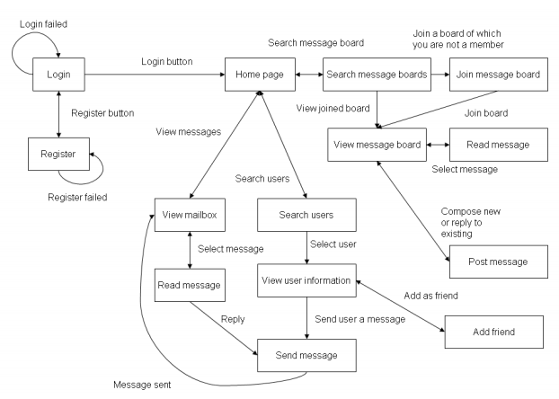
Figure 3.1 Client Screen Flow used for reference as generalised diagram for most of Social Sites

3.2.2 Use case diagrams.
A use case diagram is a graphic depiction of the interactions among the elements of a system. A use case is a methodology used in system analysis to identify, clarify, and organize system requirements. In this context, the term "system" refers to something being developed or operated, such as a mail-order product sales and service Web site. Use case diagrams are employed in UML (Unified Modeling Language), a standard notation for the modeling of real-world objects and systems.
System objectives can include planning overall requirements, validating a hardware design, testing and debugging a software product under development, creating an online help reference, or performing a consumer-service-oriented task. For example, use cases in a product sales environment would include item ordering, catalog updating, payment processing, and customer relations. A use case diagram contains four components. The boundary, which defines the system of interest in relation to the world around it.
- The actors, usually individuals involved with the system defined according to their roles.
- The use cases, which the specific roles are played by the actors within and around the system.
- The relationships between and among the actors and the use cases.

Login form:
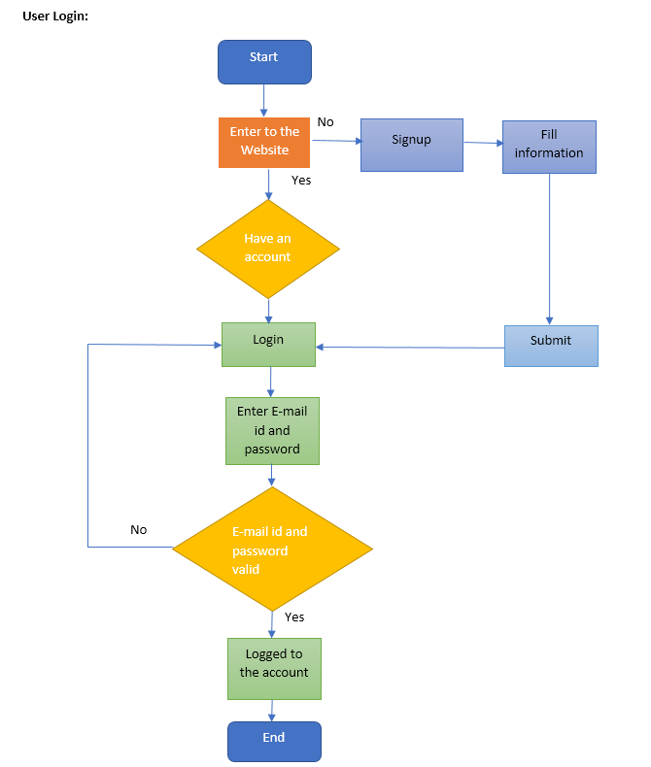
Fig 1.0 Login/Registration
Registration form:

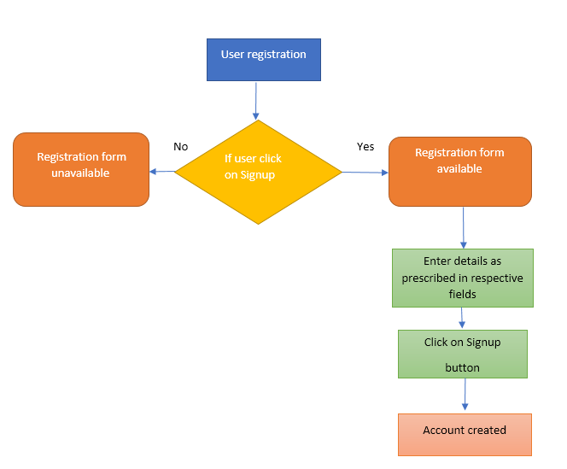
Fig 1.1 Registration

Forgot password:
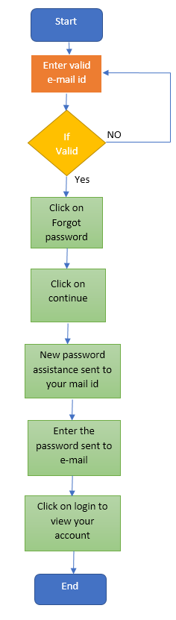
Fig 1.2 Forgot password

- SCHOOL CONNECT Home Page
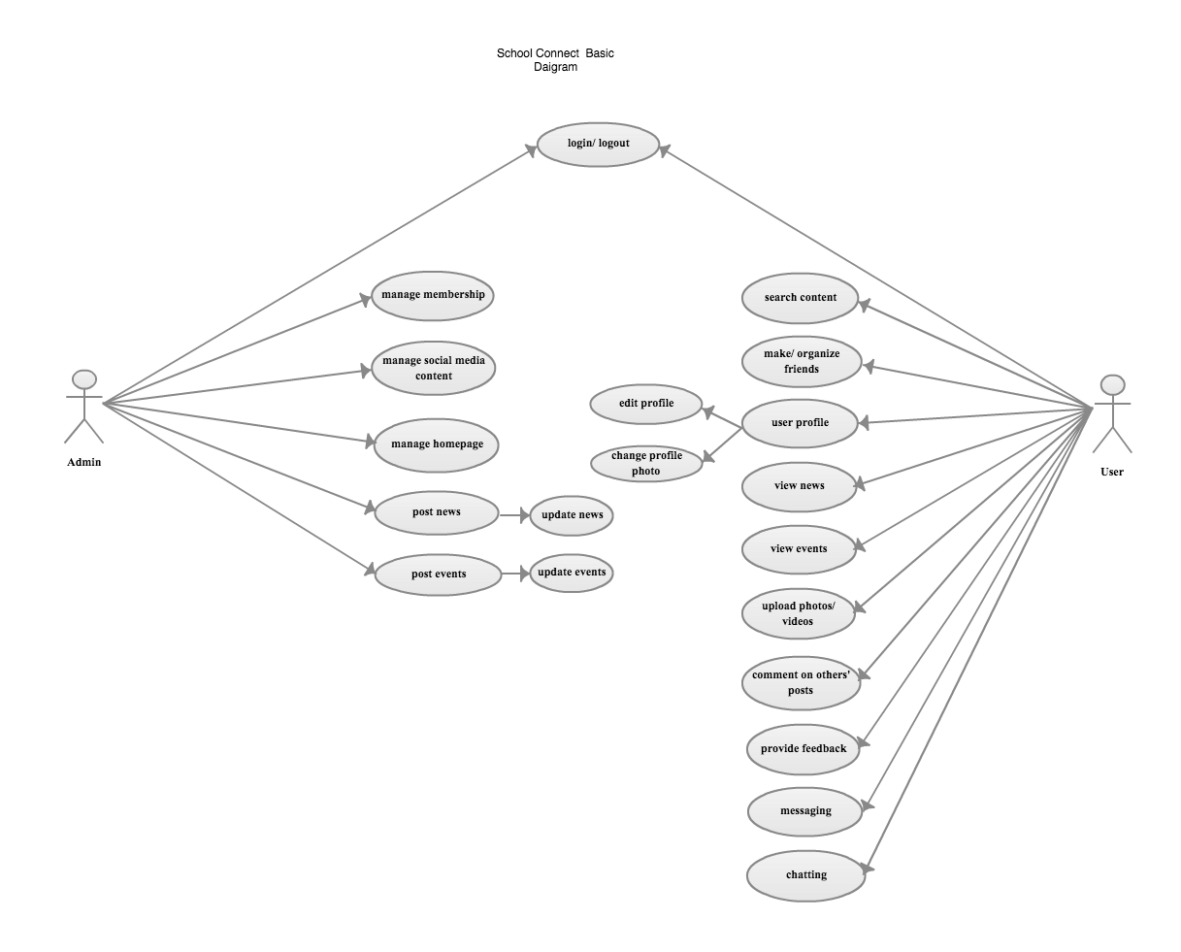
Fig 1.3 School Connect homepage

School Wall Page

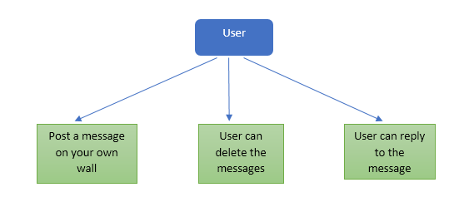
Fig 1.4 School Wall page

School Blog Page
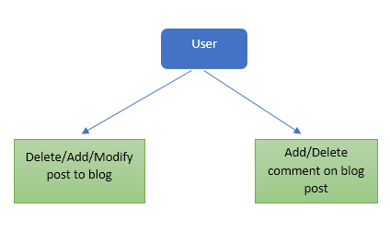
Fig 1.5 School Blog page

Profile Page

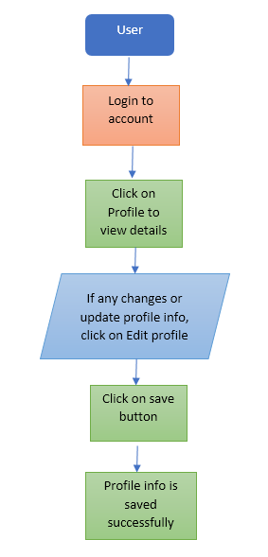
Fig 1.6 School Profile page

Search School Page
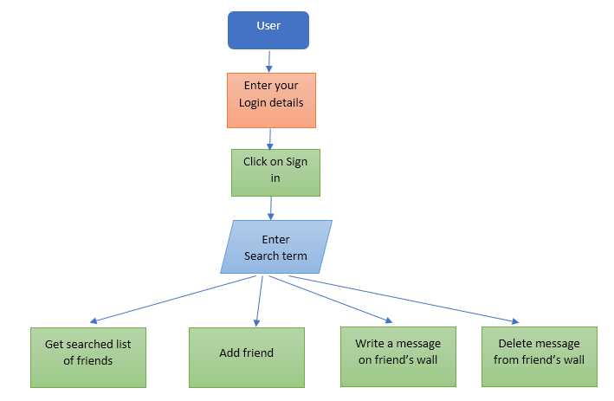
Fig 1.7 Search School page

School Connect List Page
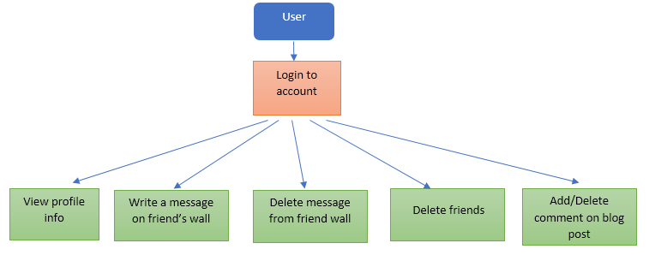
Fig 1.8 School Connect List Page

User Photo Page
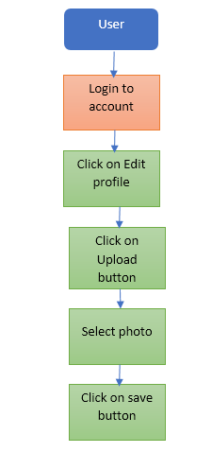
Fig 1.9 User Photo page

3.2.3 Context Diagram
The highest-level data flow diagram is the context diagram.
• The context diagram shows the interaction of the system with its environment in terms of data flows
• The context diagram defines the boundary of the system (the scope of the system)
• Only the data flows which leave the system and the data flows which come from outside the system are shown.
0 Level DFD: A level 0 DFD, also called a fundamental system model or context diagram represents the entire software element as a single bubble with input and output data indicated by incoming and outgoing arrows, respectively.

USER
UUuUUUUUU
ADMIN

Response received

Login
Views Personal detail
Send Invitation Response received
Views Mail Message Entered new data or existing
data update

Fig 3.10 0 level DFD

1 Level DFD:
This level of DFD provide more detailed structure. It provides a detailed view of requirements and flow of data from 1 bubble to another.
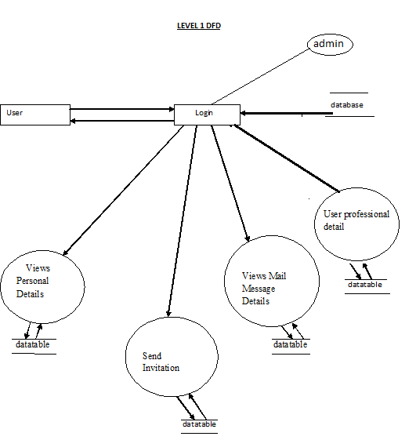

Fig 2.0 level DFD

3.2.4 SCHOOL CONNECT ENTITY RELATIONSHIP DIAGRAM

The entity relationship model is a high-level data model. It is based on a perception of a real world that consists of a collection of basic objects, called entities, and of relationship among these objects. It was developed to facilitate database design by allowing specification of an enterprise schema, which represent the overall logical structure of a database.
Entity: An entity is an object that has its existence in the real world. It includes all those “things” about which data is collected. An entity may be a tangible object such as a student, a place or a part. It may also be non-tangible such as an event, a job title or a customer account. For example, if we say that a customer buys goods, it means customer and goods are entities.
Diagrammatically, entities are represented in rectangles.

An Entity Set: It is a set of entities of the same type that share the same properties, or attributes. The set of all persons who are customers at a given bank, example, can be defined as the entity set customer.
Attributes: Attributes are units that describe the characteristics or properties of entities. In a database, entities are represented by tables and attributes by columns. For example, a customer entity might have numerous attributes such as code, name and addresses. Similarly, the goods entity may have attributes like code and price. They are drawn in elliptical shapes along with the entity rectangles.
The entity relationship diagram of mailing system is drawn on the next page:

ENTITY RELATIONSHIP DIAGRAM

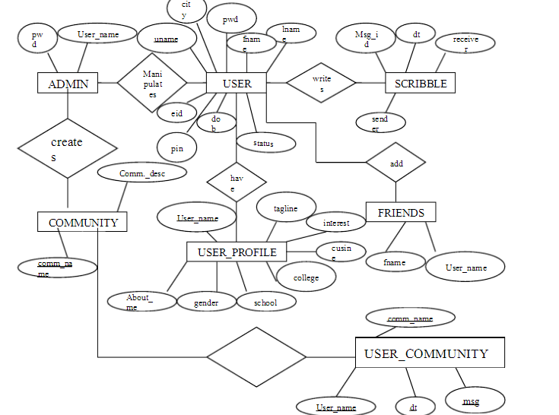

Fig 2.1 ERD

4.0CONNECTION AND COLLECTION OF DATA PROCESS MODEL

4.1 DATA CRAWLING FORM ONLINE

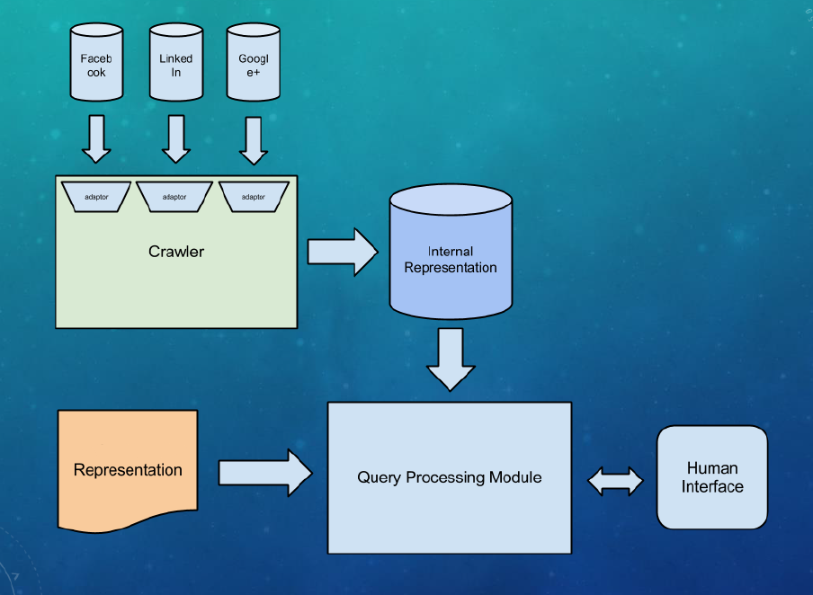

4.2 DATA CONNECTION

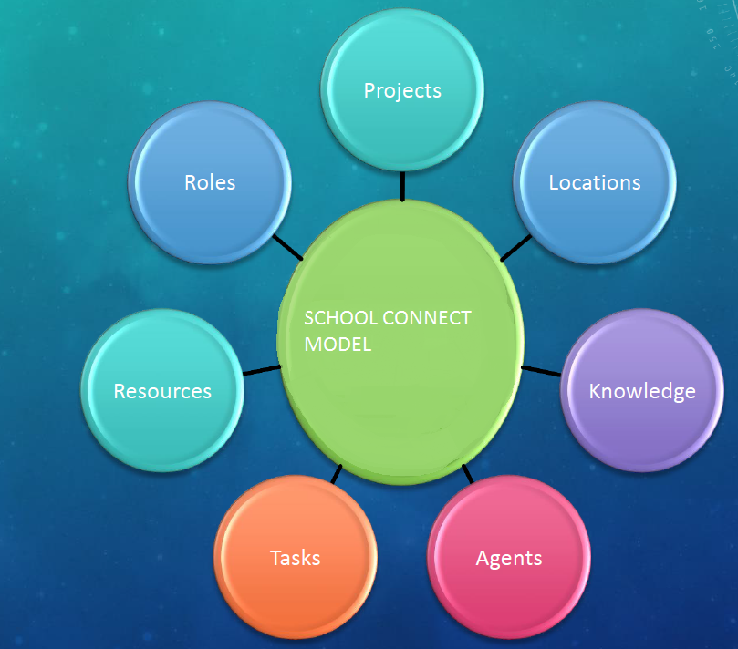

4.3 INFORMATION EVALUATION

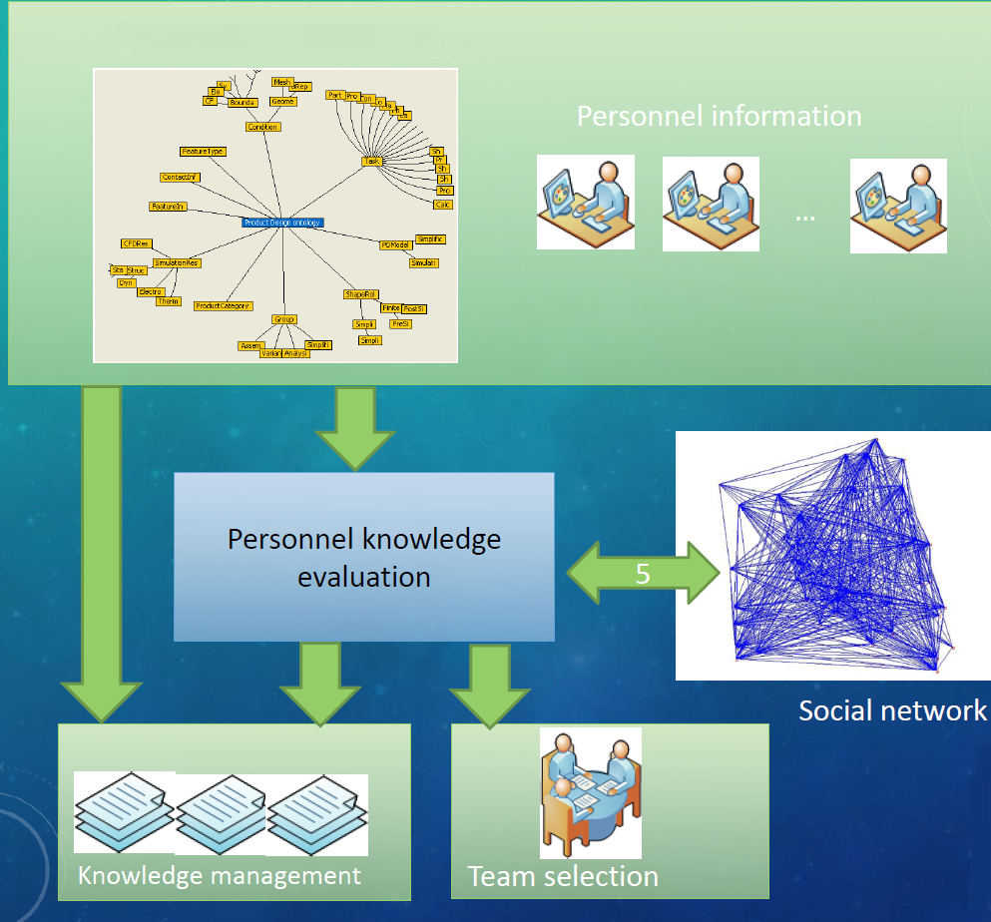

5.0 TEAM STRUCTURE

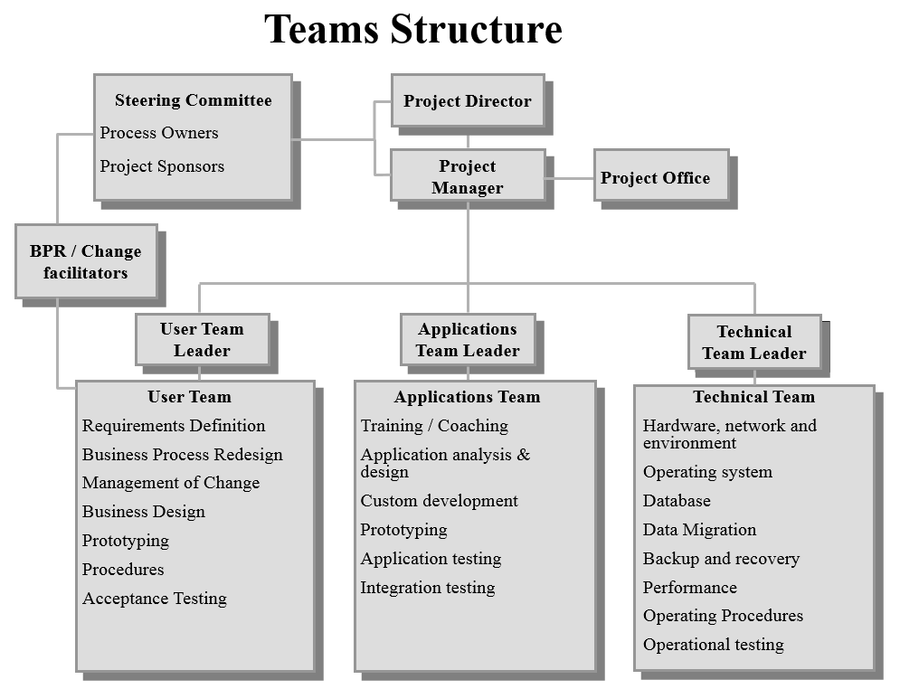

6.0 Work Breakdown Structure

School Connect
System
1
Initiation
1.1
Planning
1.2
Execution
1.3
Control
1.4
Create Preliminary Scope Statement
1.2.1
Closeout
1.5
Evaluation & Recommendations
1.1.1
Develop Project Charter
1.1.2
Deliverable: Submit Project Charter
1.1.3
Project Sponsor Reviews Project Charter
1.1.4
Project Charter Signed/Approved
1.1.5
Determine Project Team
1.2.2
Project Team Kickoff Meeting
1.2.3
Develop Project Plan
1.2.4
Submit Project Plan
1.2.5
Milestone: Project Plan Approved
1.2.6
Project Kickoff Meeting
1.3.1
Verify & Validate User Requirements
1.3.2
Design System
1.3.3
Procure Hardware/Software
1.3.4
Install Development System
1.3.5
Testing Phase
1.3.6
Install Live System
1.3.7
User Training
1.3.8
Go Live
1.3.9
Project Management
1.4.1
Project Status Meetings
1.4.2
Risk Management
1.4.3
Update Project Management Plan
1.4.4
Audit Procurement
1.5.1
Document Lessons Learned
1.5.2
Update Files/ Records
1.5.3
Gain Formal Acceptance
1.5.4
Archive Files/ Documents
1.5.5

6.0 Appendix A: Vision and Scope
7.0 Appendix B: Status Report
8.0 Appendix D: Presentation Slides
9.0 Appendix E: Other Deliverables/Artifacts

